COMP 3270 FALL 2018

**Programming Project: Autocomplete**

Name: Paul Chong Date Submitted: 26NOV18 .

1. **Pseudocode**: Understand the strategy provided for *TrieAutoComplete*. State the algorithm for the functions precisely using numbered steps that follow the pseudocode conventions that we use. Provide an approximate efficiency analysis by filling the table given below, for your algorithm.

*Add*

* Pseudocode:

1. for i = 1 to wordArray.length

2. if (node.mySubtreeMaxWeight < weight)

3. node.mySubtreeMaxWeight = weight

4. if not (node.children.contains(i))

5. node.children.put(i, child)

6. else

7. node = node.getChild(i)

8. node.setWord(word)

9. node.setWeight(weight)

10. node.isWord = true

* Complexity analysis:

|  |  |
| --- | --- |
| Step # 1 | Complexity stated as O(n) |
| Step # 2 | Complexity stated as O(1) |
| Step # 3 | Complexity stated as O(1) |
| Step # 4 | Complexity stated as O(1) |
| Step # 5 | Complexity stated as O(1) |
| Step # 6 | Complexity stated as O(1) |
| Step # 7 | Complexity stated as O(1) |
| Step # 8 | Complexity stated as O(1) |
| Step # 9 | Complexity stated as O(1) |
| Step # 10 | Complexity stated as O(1) |

Complexity of the algorithm = O(n)

*topMatch*

* Pseudocode:

1. for i = 1 to prefixArray.length

2. if (node.children.contains(i))

3. node = node.getChild(i)

4. else

5. return ""

6. if node.myWeight == largestWordWeight

7. return node.myWord

8. while (node.myWeight != largestWordWeight)

9. for j = 1 to node.children.values

10. if child.mySubtreeMaxWeight==largestWordWeight)

11. node = child

12. return node.myWord

* Complexity analysis:

|  |  |
| --- | --- |
| Step # 1 | Complexity stated as O(n) |
| Step # 2 | Complexity stated as O(1) |
| Step # 3 | Complexity stated as O(1) |
| Step # 4 | Complexity stated as O(1) |
| Step # 5 | Complexity stated as O(1) |
| Step # 6 | Complexity stated as O(1) |
| Step # 7 | Complexity stated as O(1) |
| Step # 8 | Complexity stated as O(n) |
| Step # 9 | Complexity stated as O(n) |
| Step # 10 | Complexity stated as O(1) |
| Step # 11 | Complexity stated as O(1) |
| Step # 12 | Complexity stated as O(1) |

Complexity of the algorithm = O(n2)

*topMatches*

* Pseudocode:

1. PriorityQueue nodeList = new PriorityQueue

2. List<String> wordsList = new List

3. for i = 1 to prefixArray.length

4. if (node.children.contains(i))

5. node = node.getChild(i)

6. else

7. return wordsList

8. nodeList.add(node)

9. while (nodeList.size() > 0)

10. node = nodeList.poll()

11. if (node.isWord)

12. wordsList.add(node.myWord)

13. if (wordsList.size() >= k)

14. break

15. nodeList.addAll(node.children)

16. return wordsList

* Complexity analysis:

|  |  |
| --- | --- |
| Step # 1 | Complexity stated as O(1) |
| Step # 2 | Complexity stated as O(1) |
| Step # 3 | Complexity stated as O(n) |
| Step # 4 | Complexity stated as O(1) |
| Step # 5 | Complexity stated as O(1) |
| Step # 6 | Complexity stated as O(1) |
| Step # 7 | Complexity stated as O(1) |
| Step # 8 | Complexity stated as O(1) |
| Step # 9 | Complexity stated as O(n2) |
| Step # 10 | Complexity stated as O(1) |
| Step # 11 | Complexity stated as O(1) |
| Step # 12 | Complexity stated as O(1) |
| Step # 13 | Complexity stated as O(1) |
| Step # 14 | Complexity stated as O(1) |
| Step # 15 | Complexity stated as O(1) |
| Step # 16 | Complexity stated as O(1) |

Complexity of the algorithm = O(n2)

2.**Testing**: Complete your test cases to test the *TrieAutoComplete* functions based upon the criteria mentioned below.

**Test of correctness:**

Assuming the trie already contains the terms {”ape, 6”, ”app, 4”, ”ban, 2”, ”bat, 3”, ”bee, 5”, ”car, 7”, ”cat, 1”}, you would expect results based on the following table:

|  |  |  |
| --- | --- | --- |
| Query | k | Result |
| ”” | - | Car |
| ”a” | - | Ape |
| ”ap” | - | Ape |
| ”b” | - | Bee |
| ”ba” | - | Bat |
| ”c” | - | Car |
| ”ca” | - | Car |
| ”cat” | - | Cat |
| ”d” | - | ”” |
| ” ” | - | ”” |
| ”” | 8 | {”car”, ”ape”, ”bee”, ”app”, ”bat”, ”ban”, ”cat”} |
| ”” | 1 | {”car”} |
| ”” | 2 | {”car”, ”ape”} |
| ”” | 3 | {”car”, ”ape”, ”bee”} |
| ”a” | 1 | {”ape”} |
| ”ap” | 1 | {”ape”} |
| ”b” | 2 | {”bee”, ”bat”} |
| ”ba” | 2 | {”bee”, ”bat”} |
| ”d” | 100 | {} |

3.**Analysis**: Answer the following questions. Use data wherever possible to justify your answers, and keep explanations brief but accurate:

1. What is the order of growth (big-Oh) of the number of compares (in the worst case) that each of the operations in the *Autocompletor* data type make?
2. How does the runtime of *topMatches()* vary with k, assuming a fixed prefix and set of terms? Provide answers for *BruteAutocomplete* and *TrieAutocomplete*. Justify your answer, with both data and algorithmic analysis.
   1. Brute = doesn’t matter what k is b/c it runs through entire list regardless. Brute just has a giant array and goes through 1 by 1. Once the list becomes full, it compares to first thing on the list since it’s sorted. If it is bigger than what’s on the list, get rid of top of stack and insert into new thing in stack. Over and over again
   2. Trie = as k increases, runtime increases. Loop looking for k extra things, so more k things to find the longer the run the loop runs as words are added to words list
3. How does increasing the size of the source and increasing the size of the prefix argument affect the runtime of *topMatch* and *topMatches*? (Tip: Benchmark each implementation using fourletterwords.txt, which has all four-letter combinations from aaaa to zzzz, and fourletterwordshalf.txt, which has all four-letter word combinations from aaaa to mzzz. These datasets provide a very clean distribution of words and an exact 1-to-2 ratio of words in source files.)

4. Graphical Analysis: Provide a graphical analysis by comparing the following:

1. The big-Oh for *TrieAutoComplete* after analyzing the pseudocode and big-Oh for *TrieAutoComplete* after the implementation.
   1. My pseudocode for *TrieAutoComplete* produced a time complexity of O(n2). After the implementation, the graphs that are shown below in 4(ii) seem to show an almost O(1) time complexity. However, by Googling the time complexity of a Trie data structure (source: <https://www.quora.com/What-is-the-complexity-of-Trie>), it seems that the complexity in reality is O(N * M), where N and M are two separate parts of a dataset. Thus a true depiction of the comparisons between the pseudocode and implementation may be difficult. However, with what we have so far, this is a comparison between the pseudocode and my implementation.

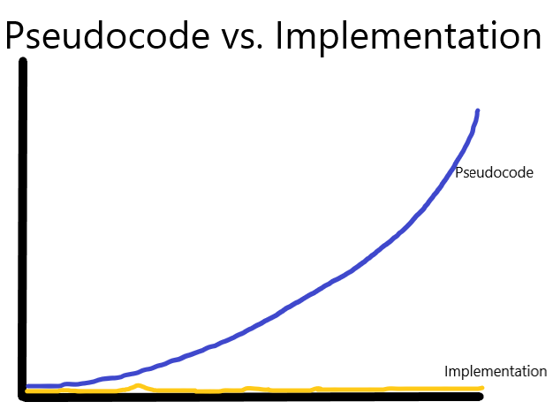

1. Compare the *TrieAutoComplete* with *BruteAutoComplete*.